Research Opportunities in the Papaj Lab
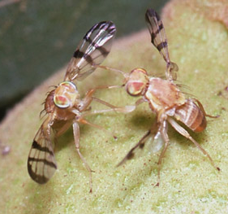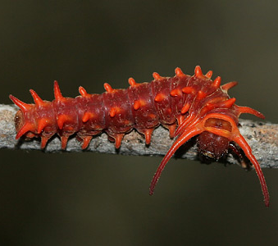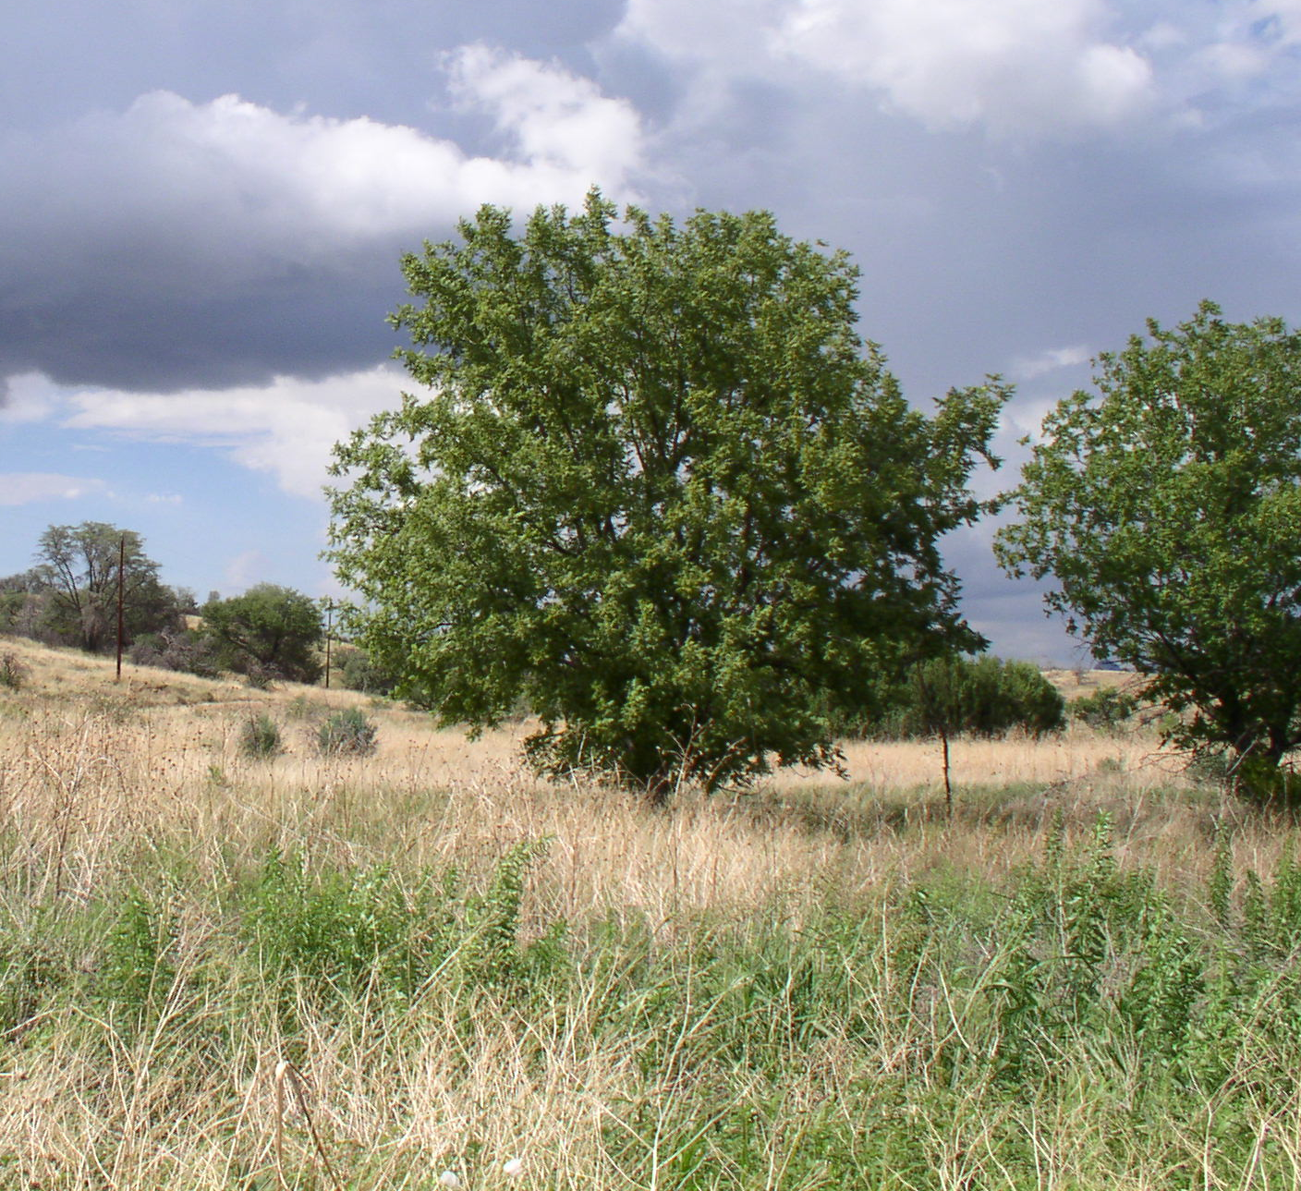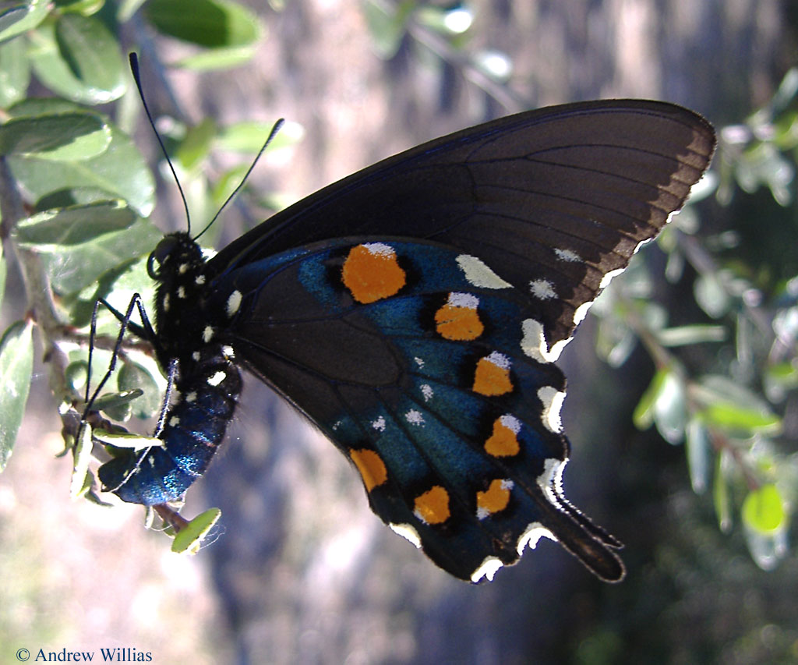
Get credit for research-
Our lab is looking for motivated undergraduate students that are interested in gaining experience in behavioral research by enrolling in research credits (ECOL 499) with us this spring.
The Papaj lab is conducting a number of research projects including studies on:
- Mulitmodal learning in bumble bees
- Color learning in butterflies
- Reproductive & territorial behavior in walnut flies
- Thermal ecology of swallowtail eggs and caterpillars
No prior experience necessary. Student researchers will be trained in behavioral observation techniques and physiological assays as well as data entry and analysis. These projects are conducted in the lab, field, or both. Preference will be given to students who have a demonstrated interest in animal behavior and to those students who would like to develop their own research project by the end of the semester.
Please contact Dan Papaj (papaj@email.arizona.edu) if interested or for further information.


